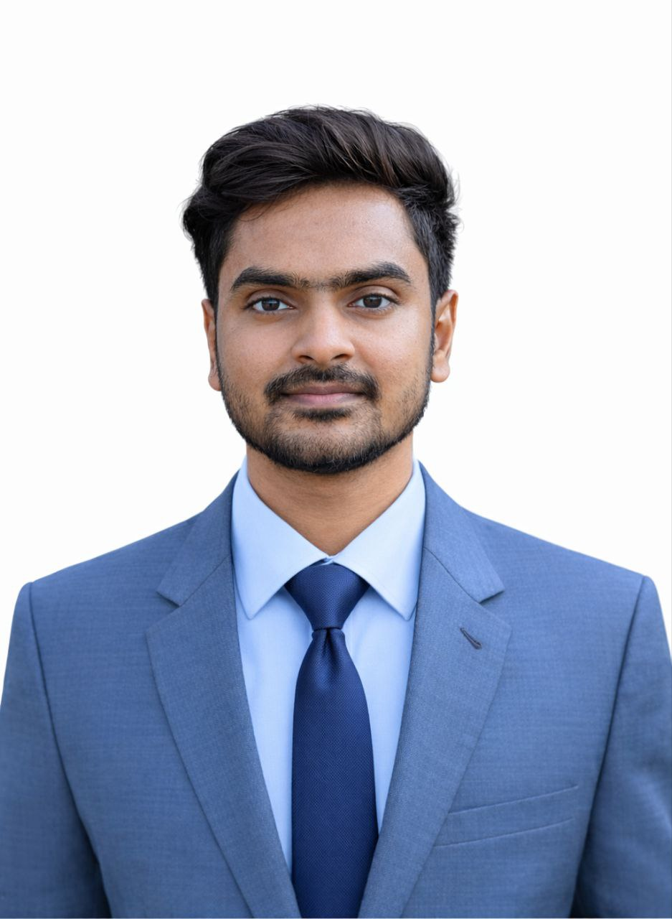
Nafiur Rahman Sabbir

Contact: 01726-665810
E-mail: nafiurrahmansabbir@gmail.com
Linkedin || Github

Career Objectives

To secure a position in an organization where I can efficiently develop and expedite my skills and potentialities. I want to be a perfect working hand of the organization to contribute to attain its goals and build my career.

Experience

Company name: OmegaSoft BD
Position: Mobile app development in Flutter Intern. (Remote)
Duration: 6 months

Project: Google Play Store publish mobile app

Medical Help Rajbari
It’s provides emergency calling, doctor appointment support, nursing services, physiotherapy services, ambulance services and medical product information with one-tap call and WhatsApp support.
- Available on play store.
- Provides 24/7 emergency calling and quick medical assistance
- Supports doctor appointment booking and consultation services
- Offers nursing, physiotherapy, and ambulance services
- Enables medical product information with one-tap call & WhatsApp support

Skills

Programming & Frameworks
- Languages: Dart, C, C++, Python, Java
- Frameworks: Flutter, Tkinter, JavaSwing
Development & Database
- State Management: GetX
- Databases: SQLite, Firebase, MySQL, Hive, Supabase
- Web Technologies: HTML/CSS, Tailwind-CSS
Strong Knowledge
- Mobile App Development with flutter

Projects: Mobile Application Development

1. MeetDoc - Smart Doctor Appointment & Telemedicine App
- Implemented doctor search, appointment booking, and video calling.
- Used Firebase for backend services including authentication, real-time database, and data storage.
- Integrated digital prescriptions, patient records, and doctor dashboards for a complete telemedicine experience.

2. SociaLive – Social Media App (Team of 4)
- Collaborated using Jira to manage tasks and maintain an Agile workflow, ensuring efficient team coordination and timely delivery.
- Built an instagram-style app using Flutter with features like posts, likes, comments, and media sharing.
- Used Supabase for authentication, real-time database, and backend services.

3. Weatherly – Flutter Weather App
- Using OpenWeather API displayed real-time weather data: temperature, humidity, wind speed, and forecast based on user location

Training and Certification

App Development with Flutter
- Mobile Application Development (6-Month Online Course, OSTAD).
- Learned Dart programming, responsive UI design, Firebase, and REST API integration.
- Built projects including an E-Commerce App, Task Manager App, and CRUD App.

Academic Qualifications

B.Sc. in Computer Science and Engineering
Daffodil International University
Result: CGPA-3.30(Out of 4)
Passing Year: 2025

H.S.C : Higher Secondary Certificate
Group: Science
Rajbari Govt. Collage
Passing Year: 2020
Result: GPA-4.56 (Out of 5)
Board: Dhaka

S.S.C : Secondary School Certificate
Group: Science
Rajbari Govt High School
Passing Year: 2018
Result: GPA- 4.17 (Out of 5)
Board: Dhaka

Personal Strength

- Strong knowledge with Mobile App Development.
- Strong knowledge with Flutter.
- Excellent communication & interpersonal skills.
- Outstanding flexibility & adaptability with changes.
- A quick learner & need minimum supervision to work.
- Capable to work under immense pressure.
- A good team player & able to work with multiple people.

Language Skill

- Bengali: Mother Language
- English: Proficient in English

Personal Information

Name : Nafiur Rahman Sabbir
Father’s Name : Habibur Rahman
Mother’s Name : Jahanara Begum
Permanent Address : Vill: Sajjankanda , P.O: Rajbari-7700
P.S: Rajbari Sadar, Dist: Rajbari
Date of Birth : 10th January 2003
Gender : Male
Nationality : Bangladeshi (By birth)
National ID No. : 5564104932
Marital Status : Unmarried
Religion : Islam
Blood Group : A+ (Positive)

Reference

1. Md. Ashraful Islam Talukder
Senior Lecture,
Daffodil International University
Email: ashrafulislam.cse@diu.edu.bd
2. Rafat J.M
Software Engineer, Vivasoft Limited
Email: rafat.meraz@vivasoftltd.com

Declaration

I do hereby declaration that all information presented here is true to my knowledge.

--------------------------------
Signature

Date:

